React redux is a libraries of react js

React redux is used to state management

React redux pass uni-directional of data

Redux is used to allow us to read react components data from a Redux store.

Redux dispatch actions to store to update data.

Redux help apps to scale by providing a sensible way to manage state through a unidirectional data flow model

A state management systems for cross-component or app-wide state
Redux used a wide for web applications.

Redux is an libraries that is used to manage data and provides more libraries to manage its data in very simple way.

Redux is a useful solution for organizing application state and provides a predictable state container for JavaScript apps. It's a well-known framework for managing state in React projects, but it also works with Angular, Vue. js, and plain old JavaScript.

Advantage of react redux ....

1) Redux is unidrectional data flow
2) Redux used for state managements to update or store data.
3) Redux does not have Dispatcher concept
4) Redux has an only one store where as flux has store.
5) Redux action objects will be recieved and handeled directly by store
6) Redux provides a complex architectures
7) It encourage a good 'React architectures'

React Redux life cycle ..…

React redux life cycle structured ….

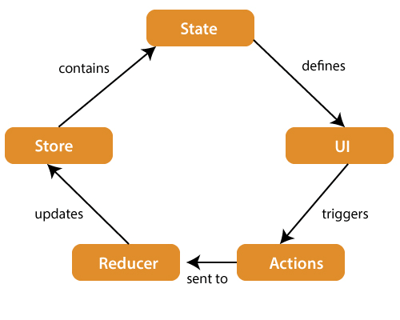

a) state
b) ui(user interface)
c) actions
d) reducer(core function)
e) store

a) store ..
a) A store is place where the entire state of your applications lists.
b) it manages the status of the applications and has a dispatch(action) in function
c) it is a like a brain that is resposible for all moving parts in Redux.
b) action..
a) Action is sent or dispatched from the view which are payloads that can be read by reducres.
b) It is a pure object created to store the information of users event.
c) It includes informations such as type action , time of occurence, location of occurence.
d) Its cordinates with state and its aim to change something in apps.

c) reducer..

a) Reducer is one type of functions where we access some globals variables also.

b) Reducer read the payloads from action and then performed updates the store via the state.

c) It is pure function to return view state from the initial state.

How to create redux app in React js...

a) npm create vite@latest
b) npm install
c) npm react-bootstrap bootstrap sweetalert2 bootstrap-icons axios
d) npm install redux react-redux --save

